# **Compilar Conector PGE con Eclipse 2018-09 (4.9.0).**

1. **Dentro de Eclipse ir a Help _ Eclipse Marketplace**

* Instalar Spring Tool Suite 4.
* Desinstalar buildship gradle integration 3.0
* Instalar Gradle ide pack 3.8.x

1. **Importar el proyecto desde el directorio como proyecto gradle:**

* File_Import_Gradle (STS)_Gradle (STS) Project_Next

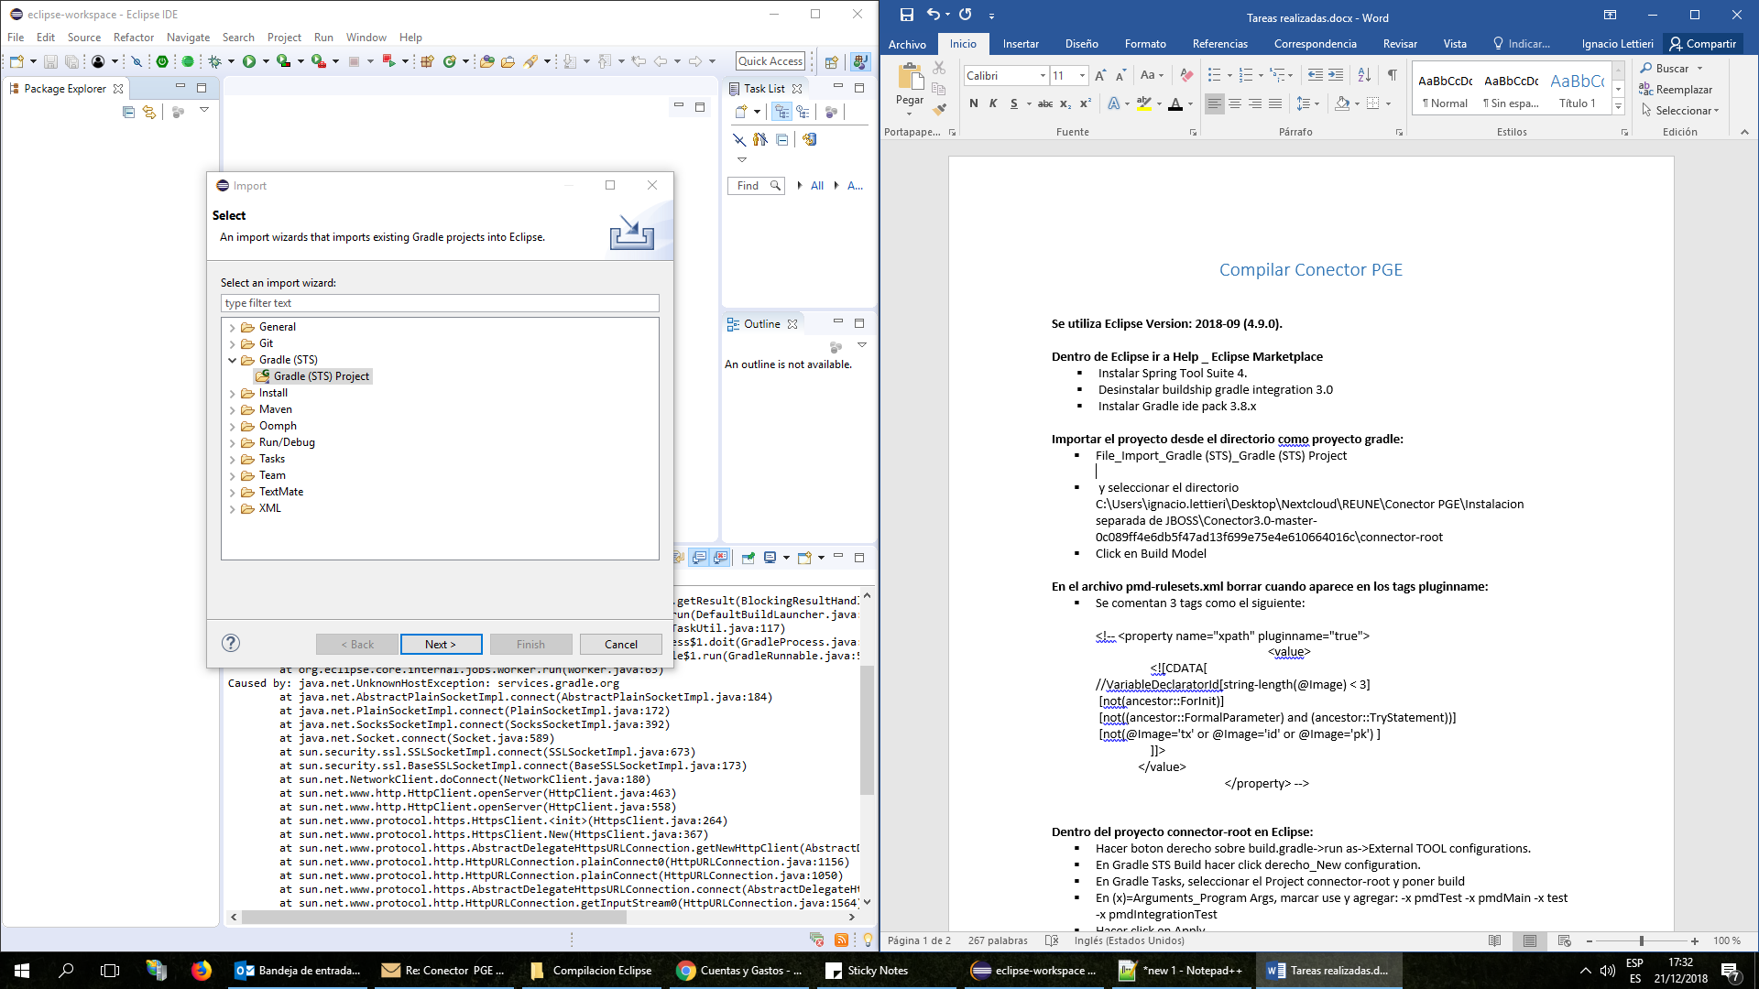

* Descomprimir el archivo Conector3.0-Fuentes.zip
* Seleccionar el directorio *C:\Users\ignacio.lettieri\Desktop\Nextcloud\REUNE\Conector PGE\Compilacion Eclipse\Conector3.0-master-0c089ff4e6db5f47ad13f699e75e4e610664016c\connector-root* y hacer click en Build Model

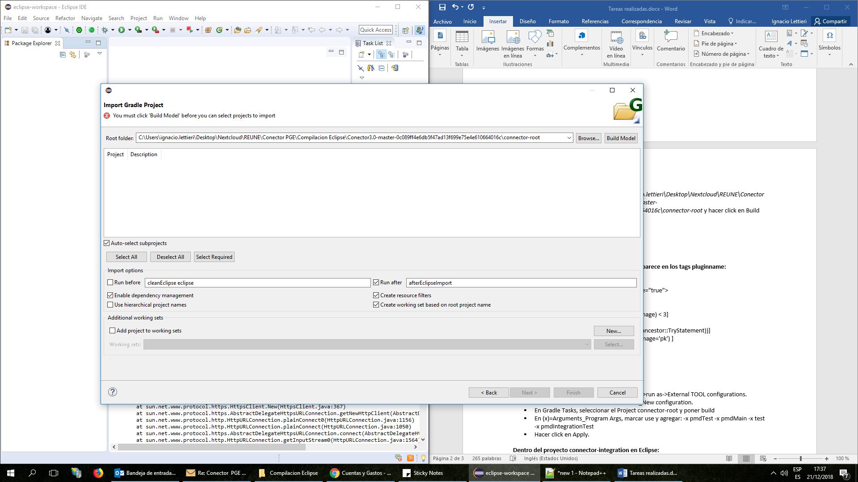

* Aparecen todos los proyectos. Seleccionar todos y hacer click en Finish

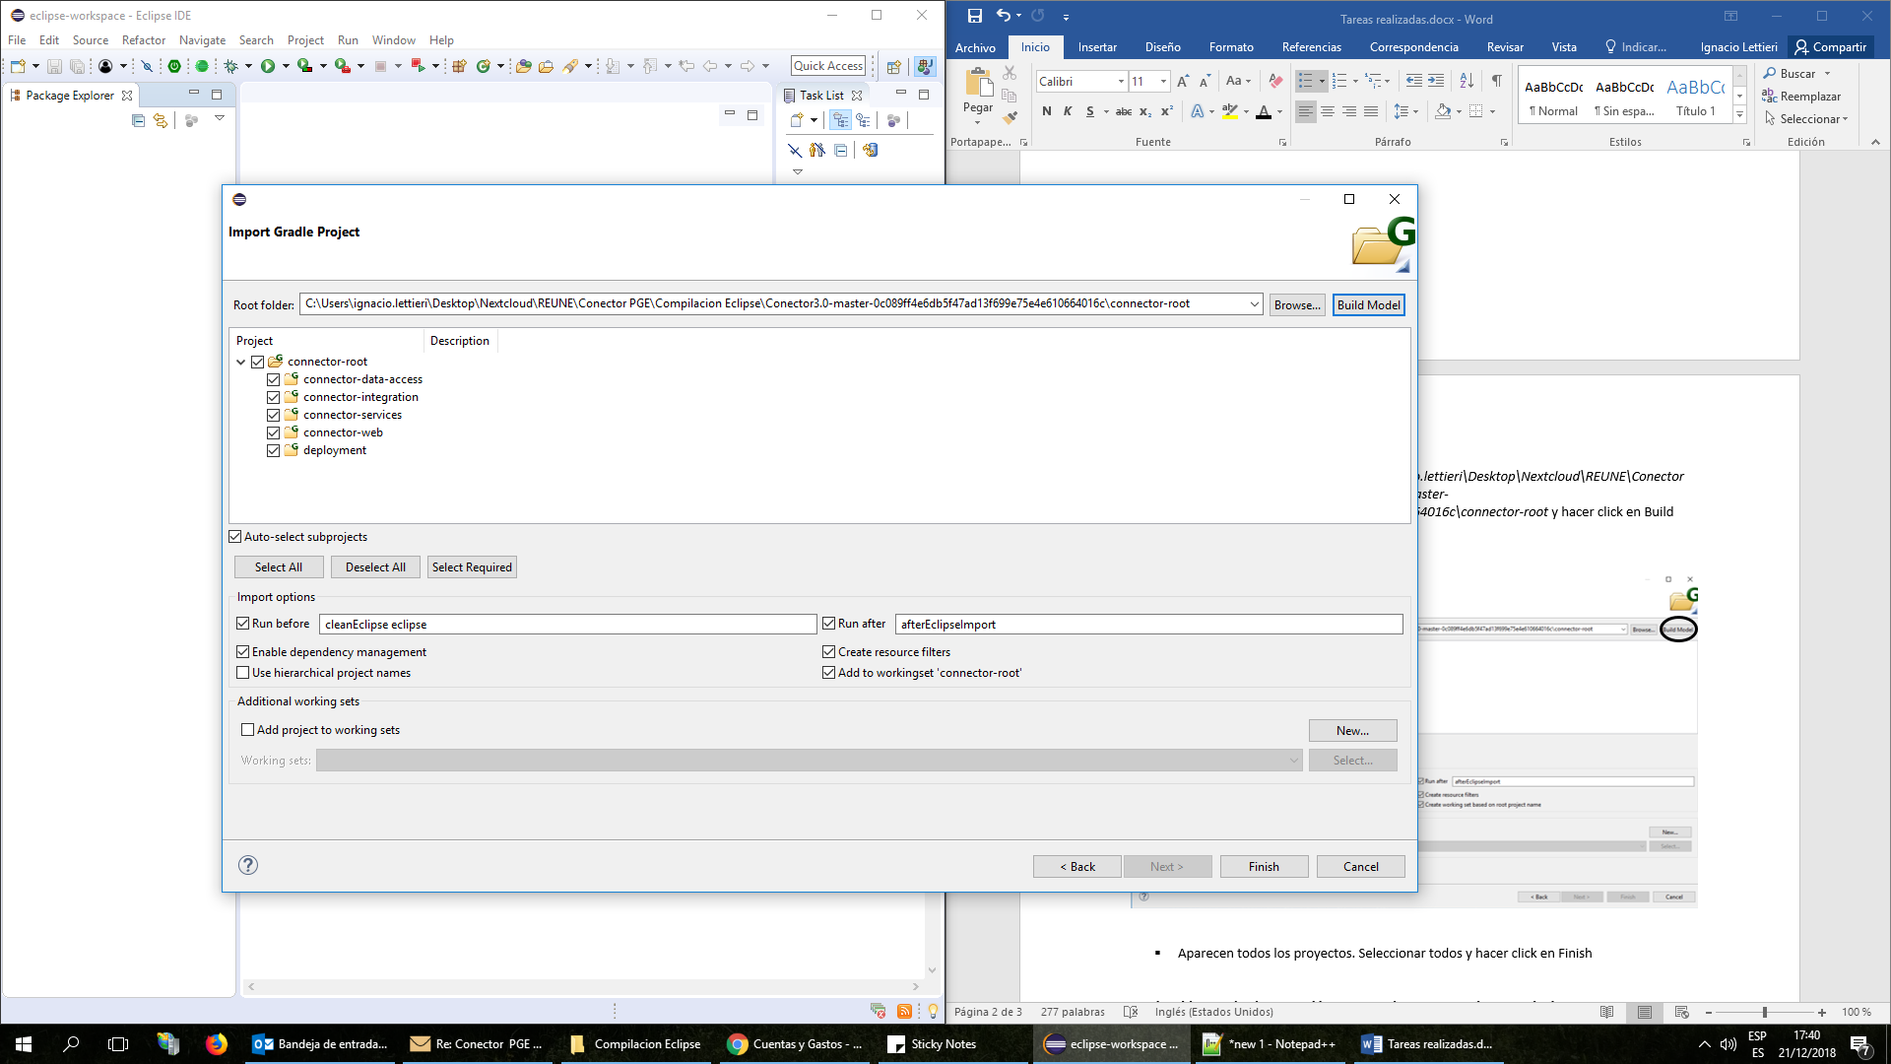

1. **Dentro del package connector-root en Eclipse:**

* Abrir el archivo Conf_pmd_pmd-rulesets.xml y visualizarlo como código.

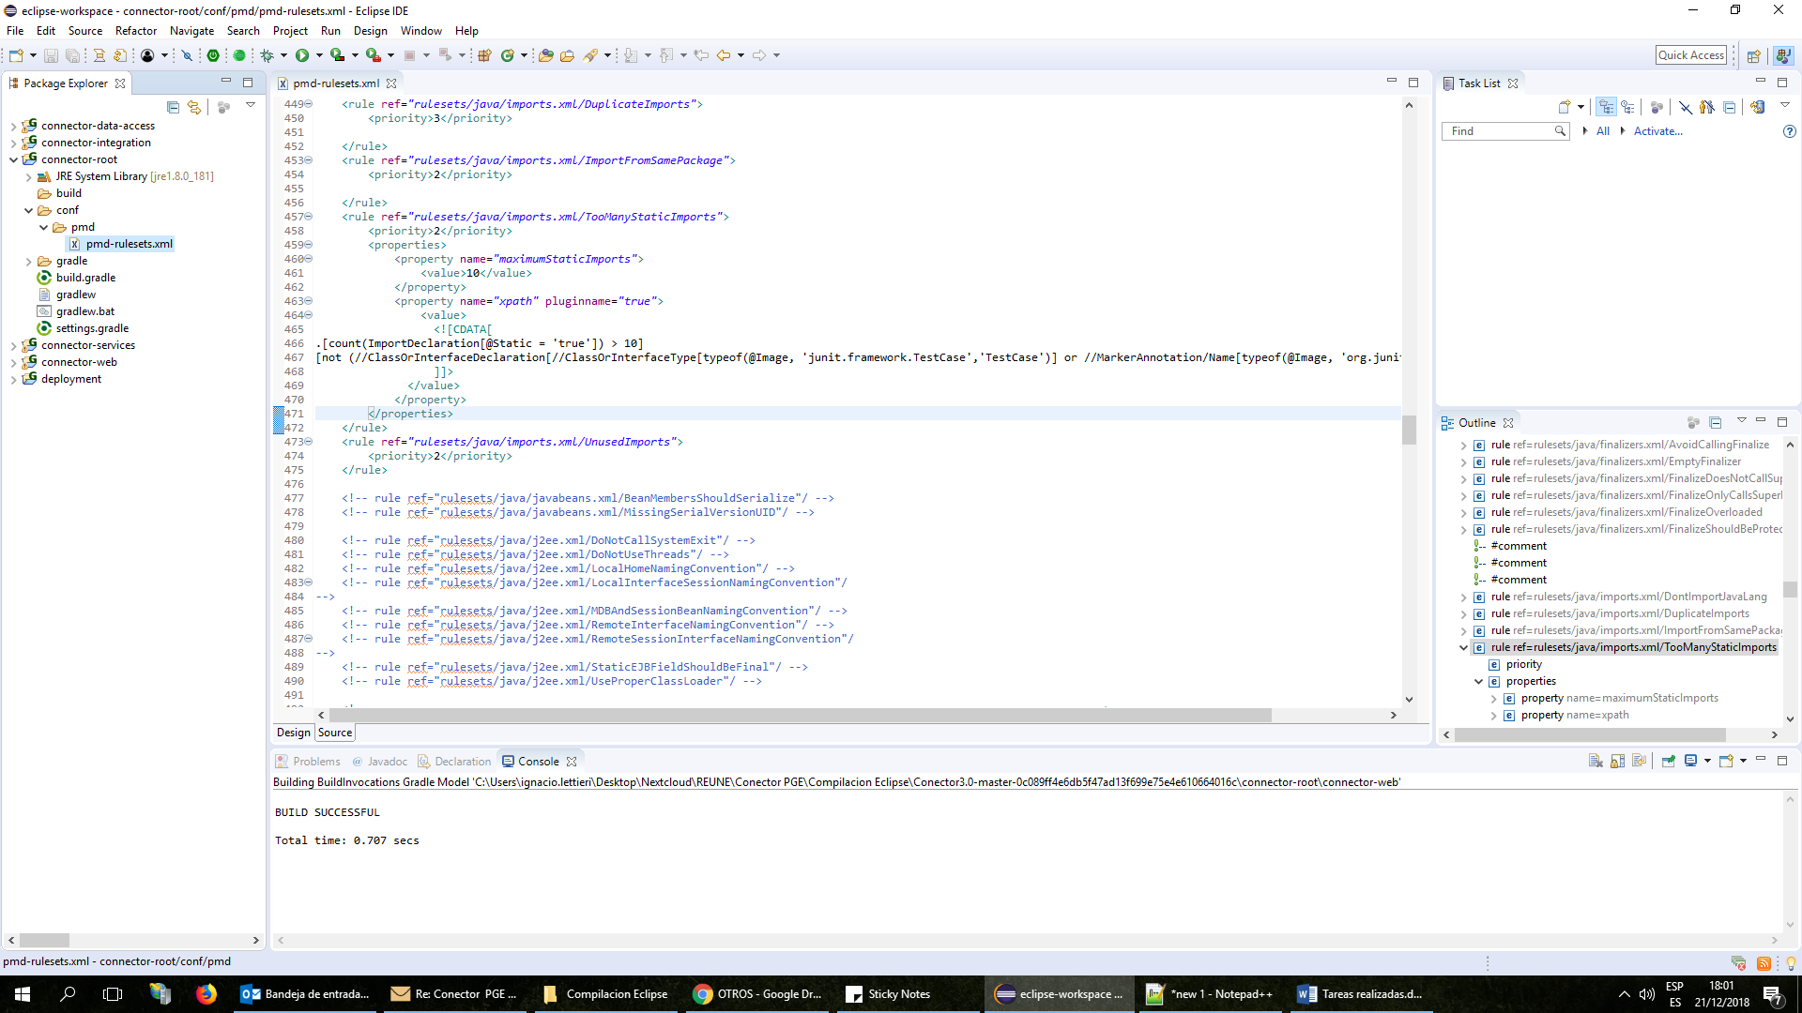

* Buscar “pluginname”

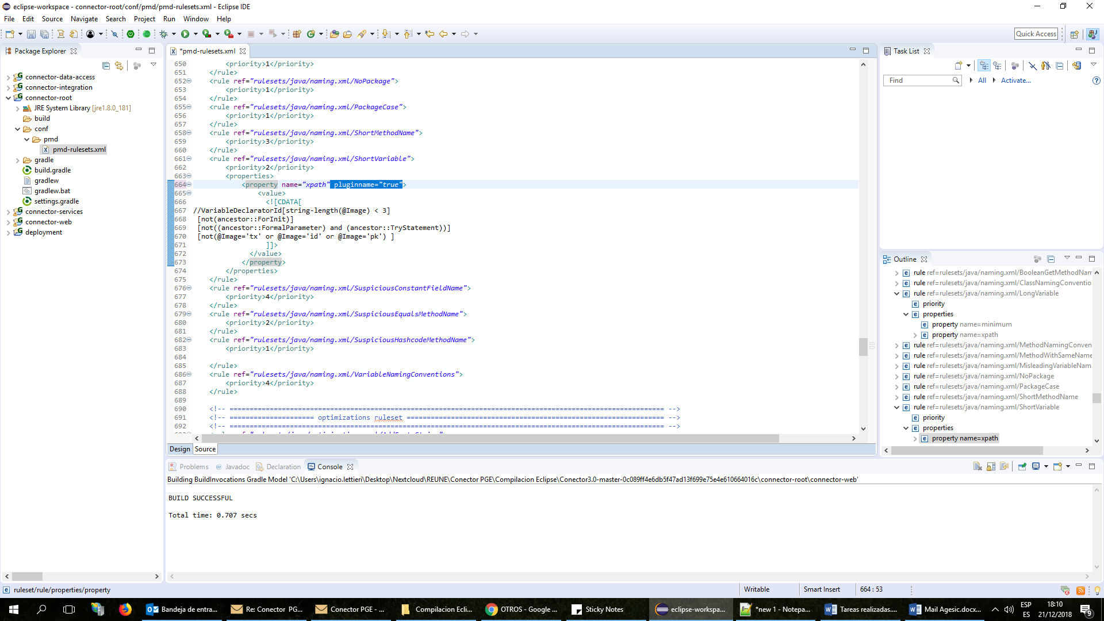

* Borrar todas las ocurrencias de *pluginname="true"*

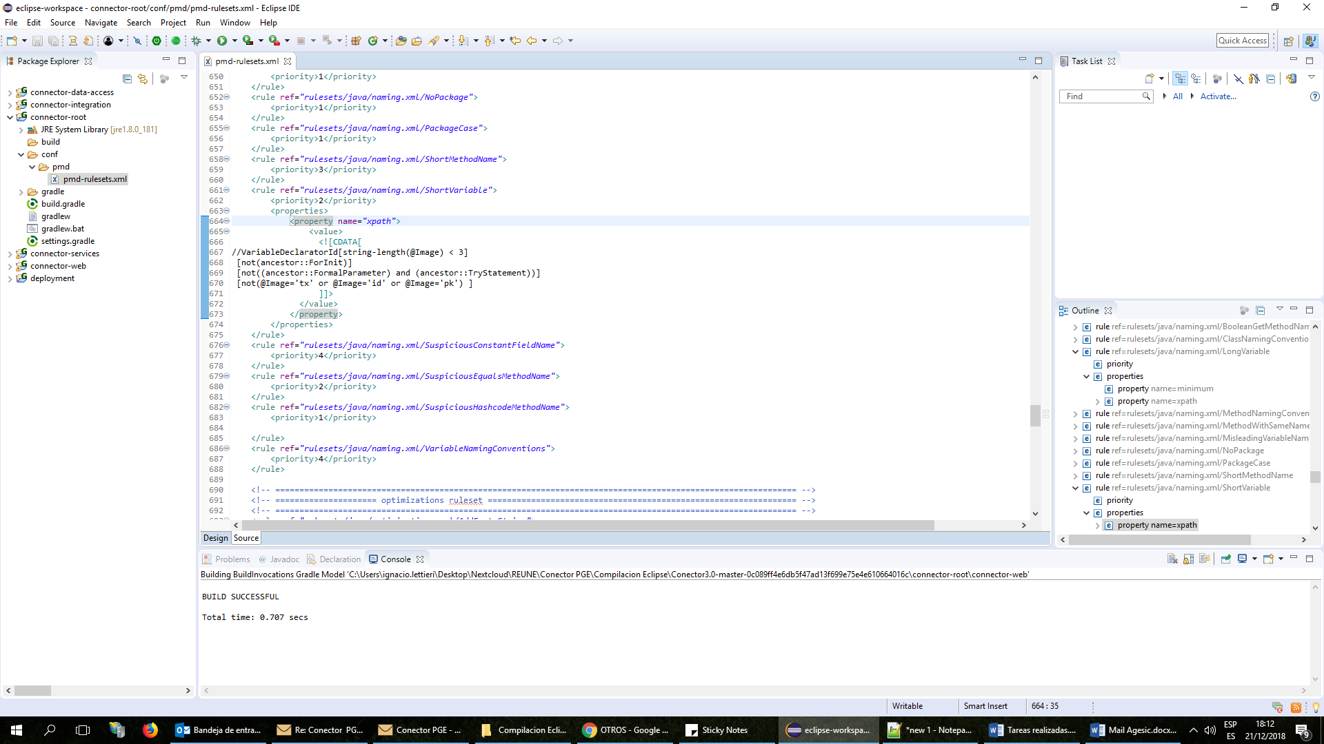

1. **Dentro del proyecto connector-root en Eclipse:**

* Hacer boton derecho sobre build.gradle->run as->External TOOL configurations.

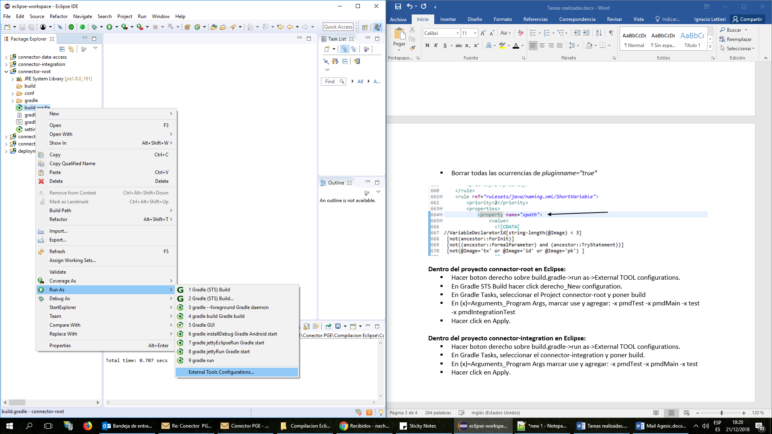

* Ir a Gradle (STS) Build y hacer click derecho_New configuration.

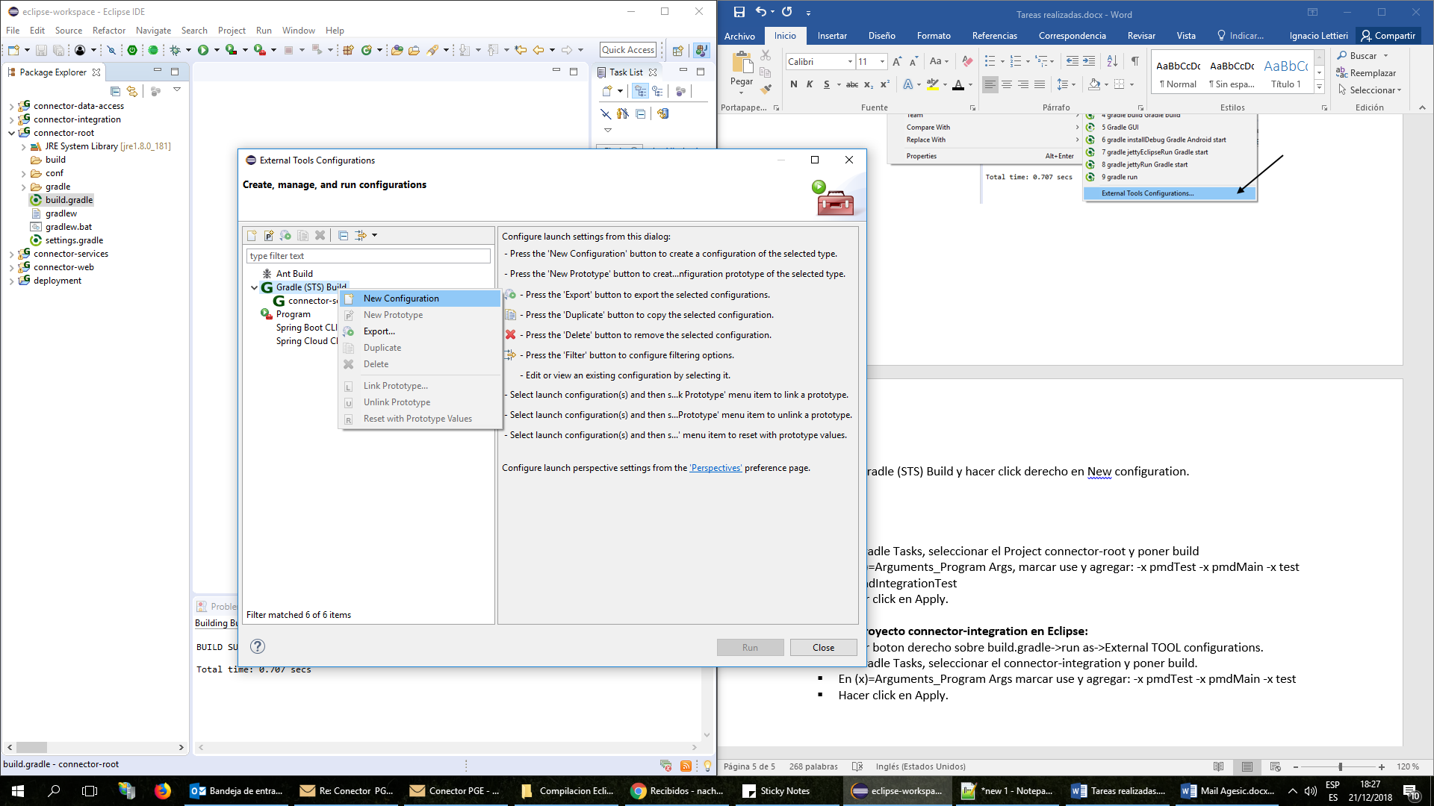

* Nombrar la nueva configuración como *connector-root*
* En la pestaña Gradle Tasks seleccionar el proyecto *connector-root* e ingresar *build*

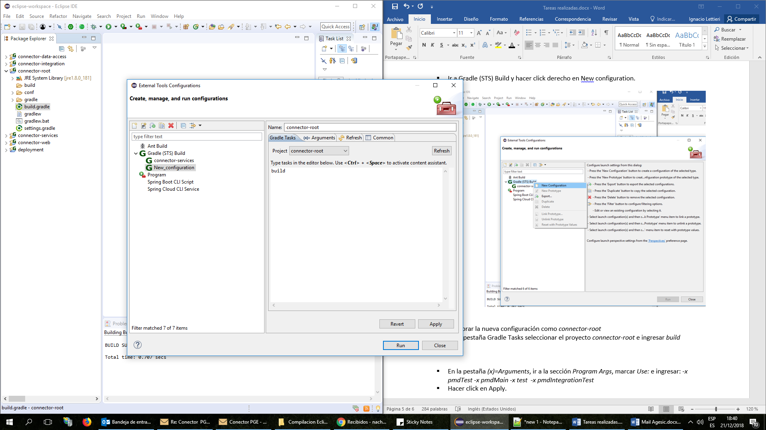

* En la pestaña *(x)=Arguments*, ir a la sección *Program Args*, marcar *Use:* e ingresar: *-x pmdTest -x pmdMain -x test -x pmdIntegrationTest*
* Hacer click en *Apply* y luego en *Run.*
* Resultado:

[sts] -----------------------------------------------------

[sts] Starting Gradle build for the following tasks:

[sts] build

[sts] -----------------------------------------------------

:connector-data-access:compileJava UP-TO-DATE

:connector-data-access:processResources UP-TO-DATE

:connector-data-access:classes UP-TO-DATE

:connector-data-access:jar UP-TO-DATE

:connector-data-access:assemble UP-TO-DATE

:connector-data-access:check

:connector-data-access:build

:connector-services:compileJava UP-TO-DATE

:connector-services:processResources UP-TO-DATE

:connector-services:classes UP-TO-DATE

:connector-services:jar UP-TO-DATE

:connector-integration:compileJava UP-TO-DATE

:connector-integration:processResources UP-TO-DATE

:connector-integration:classes UP-TO-DATE

:connector-integration:war UP-TO-DATE

:connector-integration:assemble UP-TO-DATE

:connector-integration:check

:connector-integration:build

:connector-services:assemble UP-TO-DATE

:connector-services:check

:connector-services:build

:connector-web:compileJava UP-TO-DATE

:connector-web:processResources UP-TO-DATE

:connector-web:classes UP-TO-DATE

:connector-web:war UP-TO-DATE

:connector-web:assemble UP-TO-DATE

:connector-web:check

:connector-web:build

:deployment:compileJava UP-TO-DATE

:deployment:processResources UP-TO-DATE

:deployment:classes UP-TO-DATE

:deployment:jar UP-TO-DATE

:deployment:assemble UP-TO-DATE

:deployment:check

:deployment:build

BUILD SUCCESSFUL

Total time: 1.398 secs

[sts] -----------------------------------------------------

[sts] Build finished succesfully!

[sts] Time taken: 0 min, 1 sec

[sts] -----------------------------------------------------

1. **Repetir el paso 4 para *connector-integration***

* Resultado:

[sts] -----------------------------------------------------

[sts] Starting Gradle build for the following tasks:

[sts] build

[sts] -----------------------------------------------------

:connector-data-access:compileJava UP-TO-DATE

:connector-data-access:processResources UP-TO-DATE

:connector-data-access:classes UP-TO-DATE

:connector-data-access:jar UP-TO-DATE

:connector-services:compileJava UP-TO-DATE

:connector-services:processResources UP-TO-DATE

:connector-services:classes UP-TO-DATE

:connector-services:jar UP-TO-DATE

:connector-integration:compileJava UP-TO-DATE

:connector-integration:processResources UP-TO-DATE

:connector-integration:classes UP-TO-DATE

:connector-integration:war UP-TO-DATE

:connector-integration:assemble UP-TO-DATE

:connector-integration:check

:connector-integration:build

BUILD SUCCESSFUL

Total time: 0.954 secs

[sts] -----------------------------------------------------

[sts] Build finished succesfully!

[sts] Time taken: 0 min, 0 sec

[sts] -----------------------------------------------------

1. **Repetir el paso 4 para *connector-services* quitando** *-x pmdIntegrationTest* de la pestaña (x)=Arguments, sección Program Args.

* Resultado:

[sts] -----------------------------------------------------

[sts] Starting Gradle build for the following tasks:

[sts] build

[sts] -----------------------------------------------------

:connector-data-access:compileJava UP-TO-DATE

:connector-data-access:processResources UP-TO-DATE

:connector-data-access:classes UP-TO-DATE

:connector-data-access:jar UP-TO-DATE

:connector-services:compileJava UP-TO-DATE

:connector-services:processResources UP-TO-DATE

:connector-services:classes UP-TO-DATE

:connector-services:jar UP-TO-DATE

:connector-services:assemble UP-TO-DATE

:connector-services:check

:connector-services:build

BUILD SUCCESSFUL

Total time: 0.596 secs

[sts] -----------------------------------------------------

[sts] Build finished succesfully!

[sts] Time taken: 0 min, 1 sec

[sts] -----------------------------------------------------